**BLOCKCHAIN – NAAN MUDHALVAN**

**ASSIGNMENT – 1**

Aravind R (961820105006)

Arun S (961820105007)

Arun Chripssan A (961820105008)

Beauttus BS (961820105009)

Ponjesly college of Engineering

**CODING:**

// SPDX-License-Identifier: MIT

pragma solidity ^0.8.0;

contract ZoneContract {

string public zoneName;

constructor(string memory _initialZoneName) {

zoneName = _initialZoneName;

}

function getZoneName() public view returns (string memory) {

return zoneName;

}

}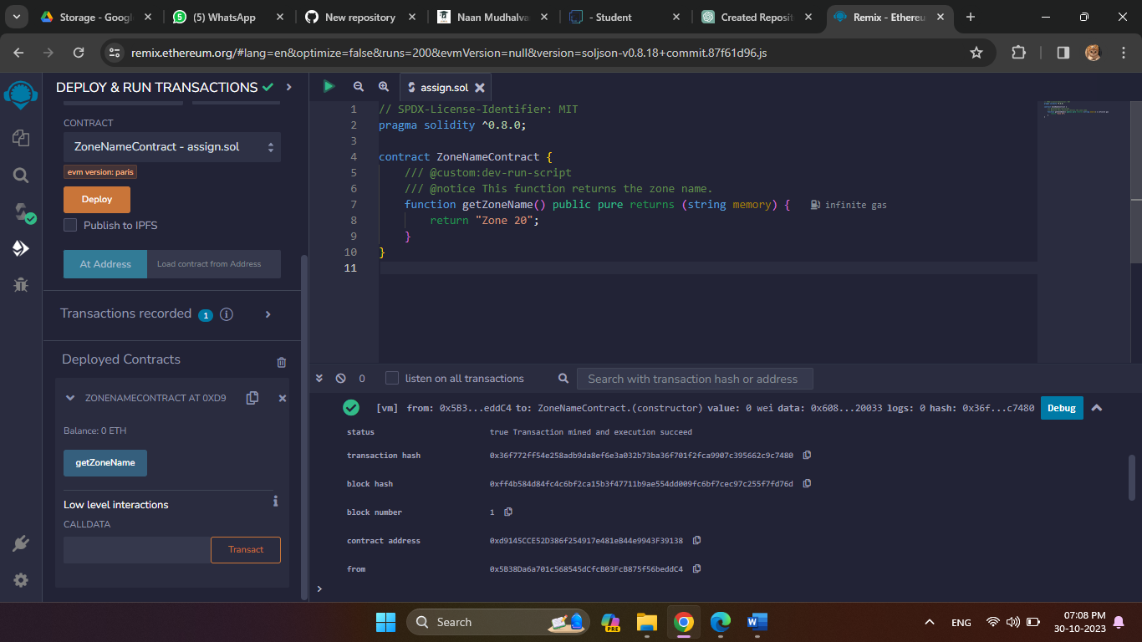

**SAMPLE OUTPUT: Remix IDE**

getZoneName

0: string: Zone 17

**OUTPUT**

**Zone 17**